What the Libraries Can Do for YOU!
Fall 2019, Willis Library

Erin O’Toole, Science Reference Librarian John Martin, Scholarly Communication Librarian
erin.otoole@unt.edu john.martin@unt.edu
It all starts here at the UNT Libraries homepage, https://library.unt.edu. Your library fees have paid for these services and resources, so get your money’s worth!

1. We’re available whenever you need us and wherever you are: https://library.unt.edu
- Ask Us: https://library.unt.edu/ask-us
- Remote access to electronic resources – navigate through the library homepage and enter your EUID and password

2. We provide specialized research help in-person and online
- Subject librarians, see Subject Librarians button on homepage
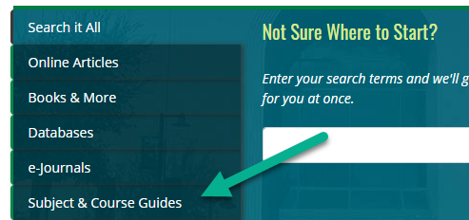
- Library guides, see Subjects & Courses tab on homepage or go to https://guides.library.unt.edu/home

3. We give you access to over 4 million books and other items through the library catalog – use the Books & More tab on the homepage.
- Catalog includes print books, e-books, print journals, e-journals, dvds, cds, government documents and more
- Similar to a Google search with options to refine
- Visit your catalog account where you can renew items
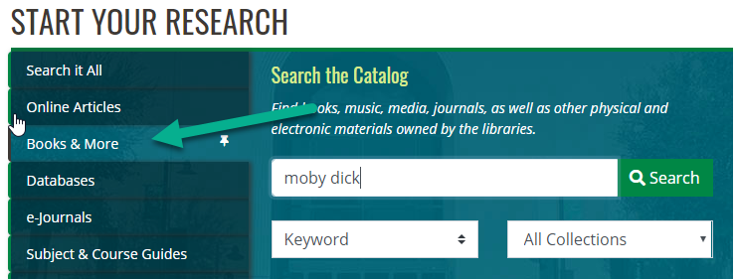
4. We give you access to over 130,000 e-journals and 500 plus databases – use the e-Journals and Databases tabs on the homepage
- Most articles available in full-text
- Majority of articles have citation features available
- Remember to search in multiple databases to do comprehensive search
- Most databases provide Boolean searching and refining
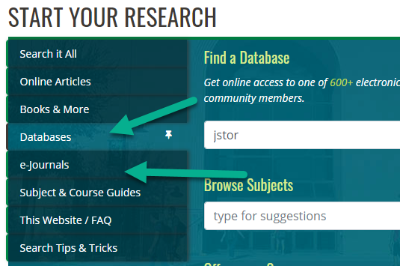

5. We get materials that we don’t own for you at no cost
- Borrowing: Interlibrary Loan link under Most Requested
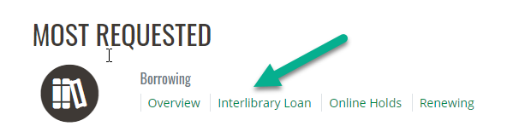
- Set up your ILLiad account to get free loans
- Get a TexShare card at https://library.unt.edu/services/texshare-cards/
6. We provide a research manager, RefWorks, to make you more productive. See Electronic Resources: RefWorks link under Most Requested at top right of homepage.
- Sign up for an account with new RefWorks at no cost
- Organize your references in folders; read and annotate documents
- Create bibliographies in citation style of your choice
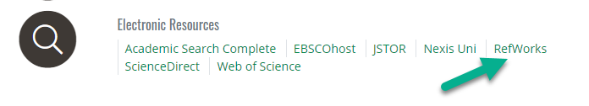
- See https://guides.library.unt.edu/rwnew for more information.

7. We provide quiet and group study areas, and you can reserve them
- Select the Spaces link on the top navigation bar of the homepage
- Use the Space Finder (Selector) to find the best room for your purposes
- See “Students: Check Availability/Reserve” on each room page to reserve a room

8. We can help you unlock paywalls by making your scholarship available through the UNT Scholarly Works collection: https://digital.library.unt.edu/ScholarlyWorks
- See usage statistics and gain a permalink for sharing your scholarship more broadly
- Preserve your datasets using the UNT Data Repository
- View open access scholarship produced by UNT’s faculty, staff, and students, including previous students’ theses and dissertations.

9. We can help you publish or disseminate your work in ethical, sustainable, and productive ways through our Scholarly Communication Office: https://library.unt.edu/scholarly-communication
- Find appropriate publication venues and learn about alternative forms of dissemination in your fields.
- Protect your author rights by learning about copyright, publication agreements, and licensing options.
- Explore the possibilities of open access publishing, OERs, and open textbooks for your publication and teaching.
- Get advice on writing grants, creating data management plans, or starting a journal.
10. We’re here to answer your questions!

